Thief
A game by Kevin and Brad
In Thief, you play as a goblin named Grug. Grugs objective is to collect as many coins as he can in one minute while avoiding the bombs that are falling from the sky. Grugs armor only allows him to take explosions from three bombs before he dies, so make sure to always watch your available lives when deciding if you want to take a bomb hit to grab some sweet coins. The game tracks your score, and displays it whether you die or time out.

The features include fluid animation for both coins and Grug. Our menu includes a help screen to get players started on how to play. We originally limited the amount of coins on screen to 3 to promote more decision making on where you want to move. Our playtesters decided that it was too slow, so we added 5 more coins to the screen.
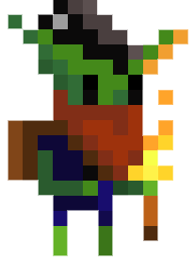
Class Name | Purpose
ActionScene | Holds all of the classes that take up the gameplay and draws them, for easier reference.
Background | Holds our background image as well as music.
Bomb | Attributes required for creating a bomb as well as hit detection with the player and explosion sound.
Coin | Attributes required for creating a coin as well as hit detection with the player and “clink” sound.
Credits | Holds our credits screen.
CreditsScene | Holds our Credits class and draws it for easier reference in Game1.
Game1 | Our main class, has scene switching and also has updates the variables on death and exit etc…
GameOver | Holds our GameOver image and also displays your final score.
GameOverScene | Holds all of the classes that take up gameover and draws them, for easier reference.
GameScene | Class we use for making different game scenes. (From AllInOne)
HelpScene | Holds all of the classes that take up help screen and draws them, for easier reference.
HelpScreen | Draws our help screen when referenced.
MenuComponent | Class we use to structure our menu system. (From AllInOne)
Player | Attributes required for drawing Grug as well as idle and running animations.
Score | Holds and tracks variables for score, time and lives and displays them.
StartScene | Holds all of the classes that take up the menu screen and draws them, for easier reference.

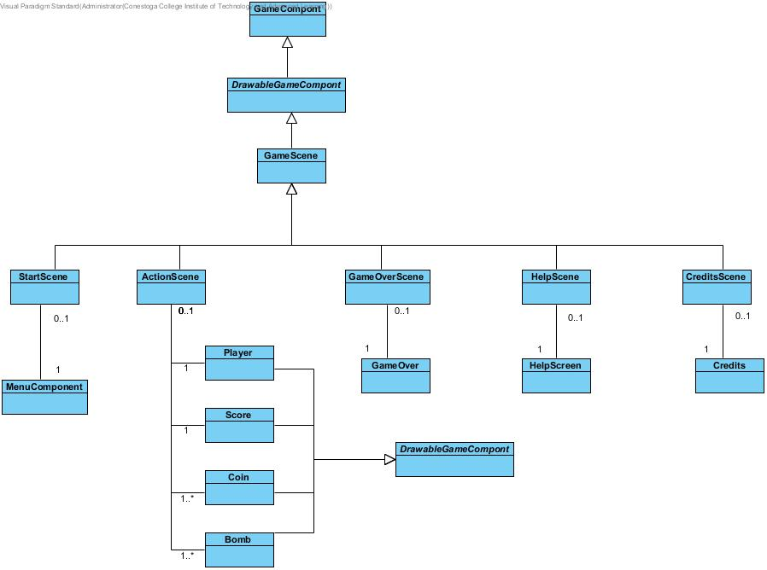

References
Grug –
https://lionheart963.itch.io/goblin-sprite
Coin –
https://img.tutpad.com/tut/0/53/24-color.png?size=%3C700x&dpr=2
Bomb –
https://i.pinimg.com/236x/c7/a2/c9/c7a2c9d5803ac7c28805a268d0af01d8--mac-os-the-bomb.jpg
Background - https://i.pinimg.com/originals/d4/98/2e/d4982e9c84ee1bc904c1d0e538a28ce4.jpg

Coin sound –
https://freesound.org/people/ProjectsU012/sounds/341695/
Bomb sound –
https://freesound.org/people/Zangrutz/sounds/155235/
Background music –
https://freesound.org/people/rhodesmas/sounds/321718/
Game Over Sound –
https://freesound.org/people/myfox14/sounds/382310/

